TASK 1:

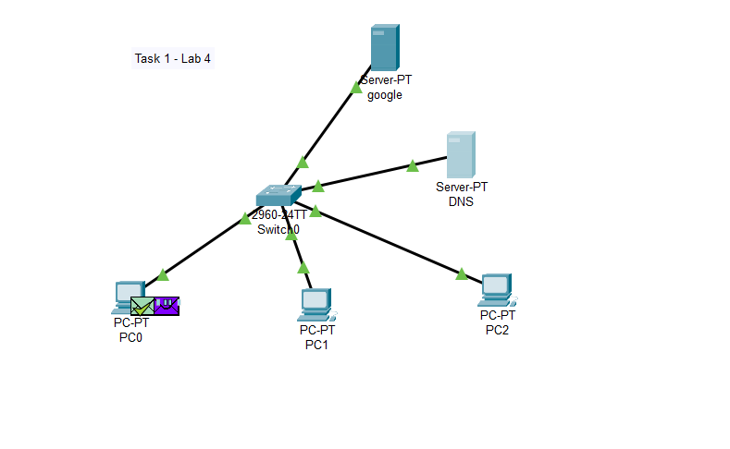
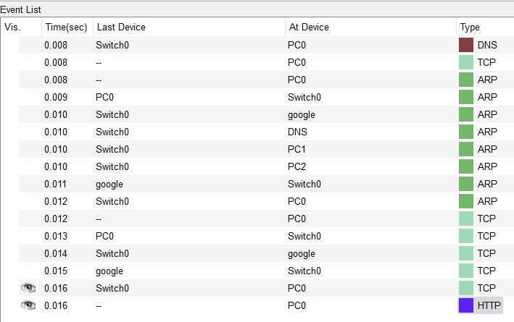

Configuration Pics:
Dedicated DNS server (‘192.168.1.2’ is the IP assigned to the dns server, so this IP will be used by different PCs to reroute) :
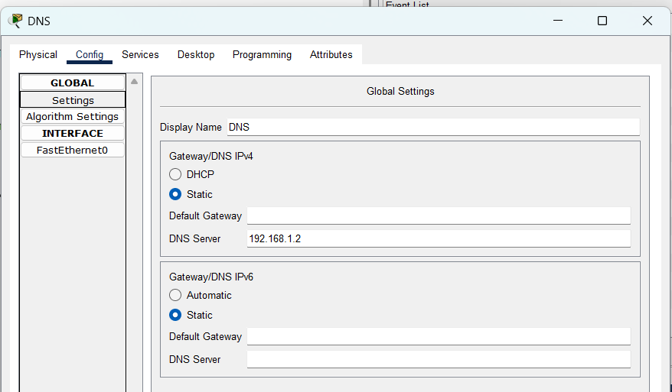
List of websites:
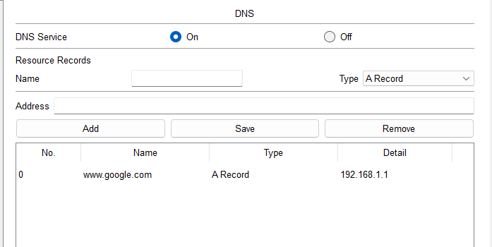

PCs configured using DHCP: (3 PCs)
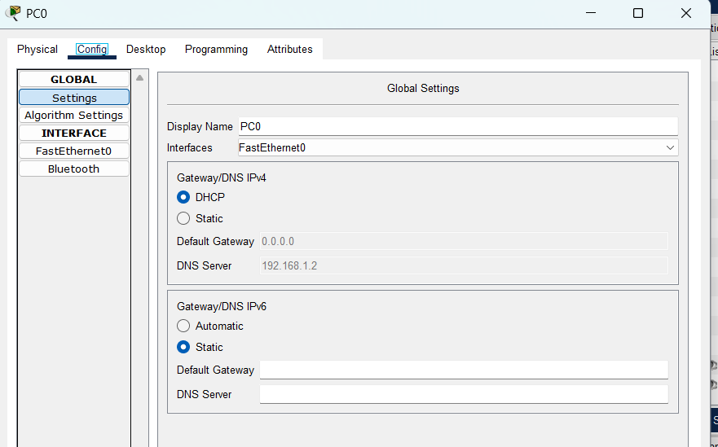
DNS PACKET working successfully:
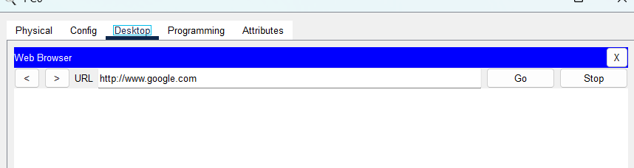

TASK 2:
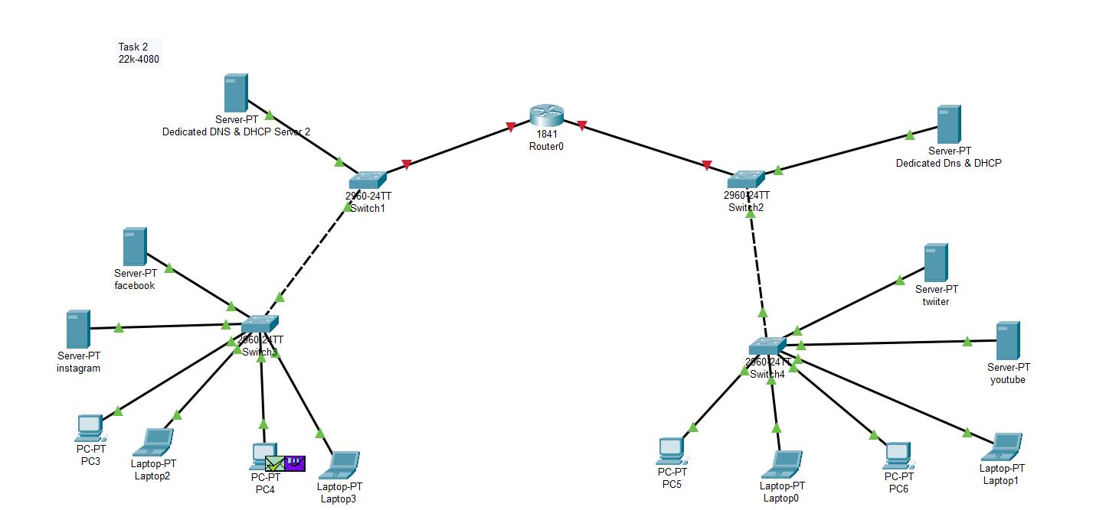

2 Dedicated DNS & DHCP Server for each network.
Packet sent successfully:
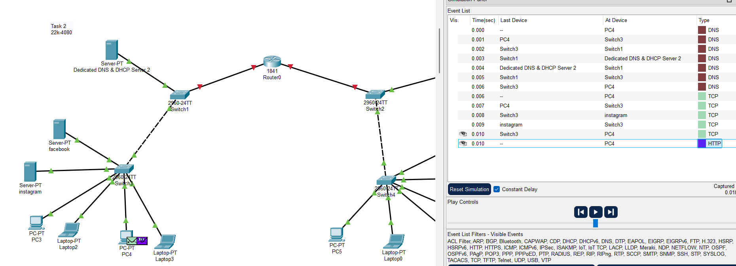
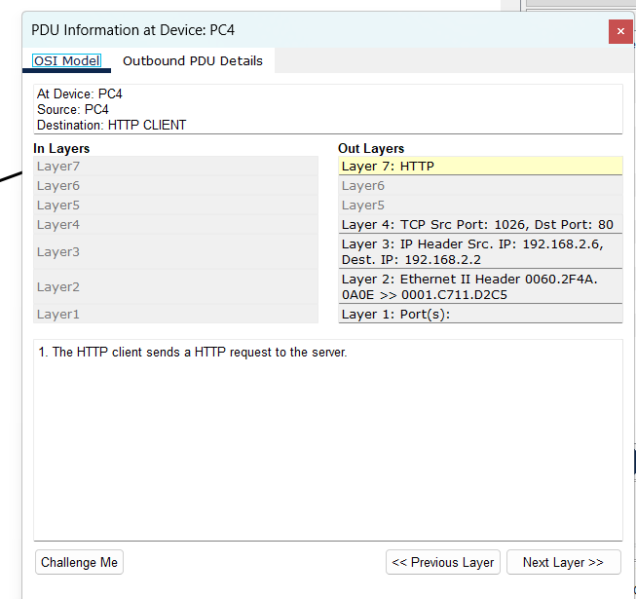
Configurations:
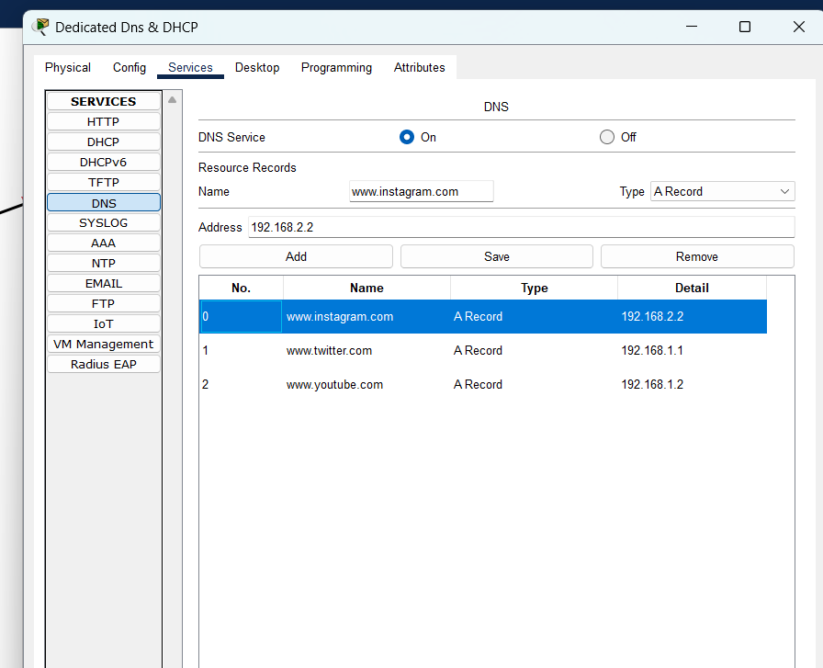
Dedicated Server 2:
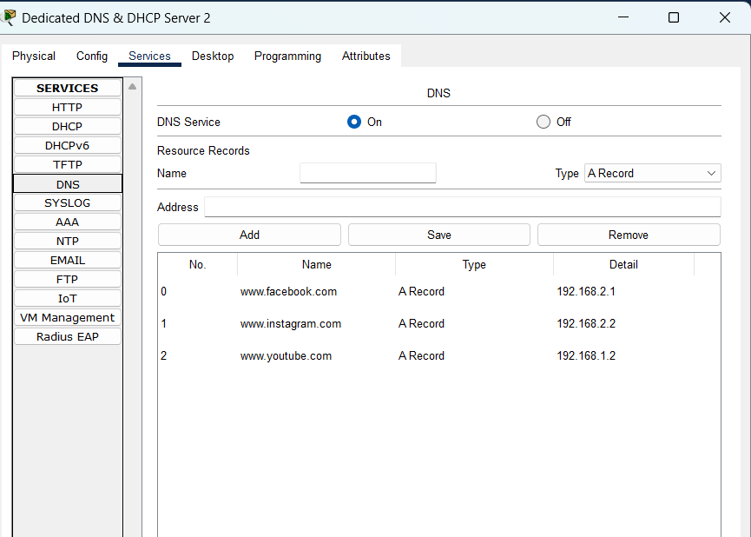

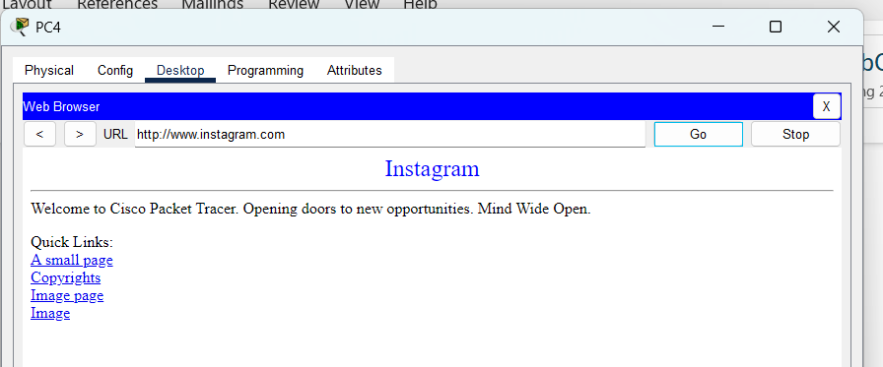
DHCP POOL:
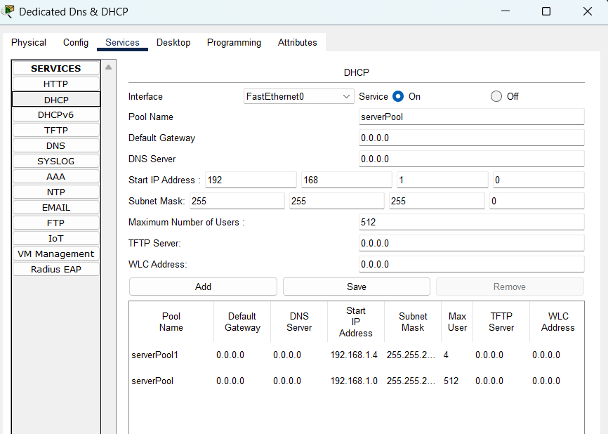
DHCP POOL 2:
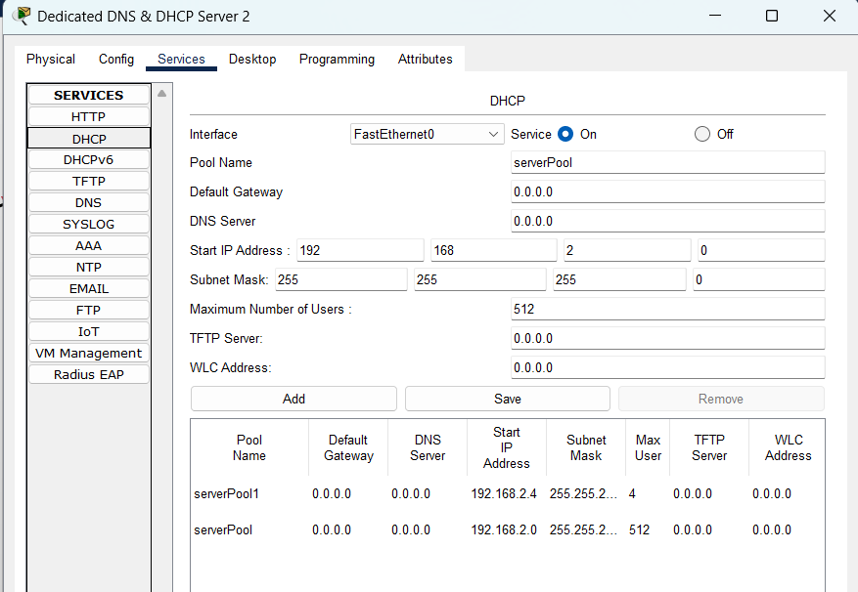
TASK 3:
Age header represents how long (in seconds) a response has been stored in a cache since it was initially fetched from the origin server.
If a cached response is too old compared to its freshness criteria, the client might request a fresh copy from the origin server.
The Expires header is set by the origin server and tells caches and clients the exact timestamp when the response should be considered old. After this time, caches must revalidate the resource with the origin server.
TASK 4 (WIRESHARK):
Data sent using HTTP:
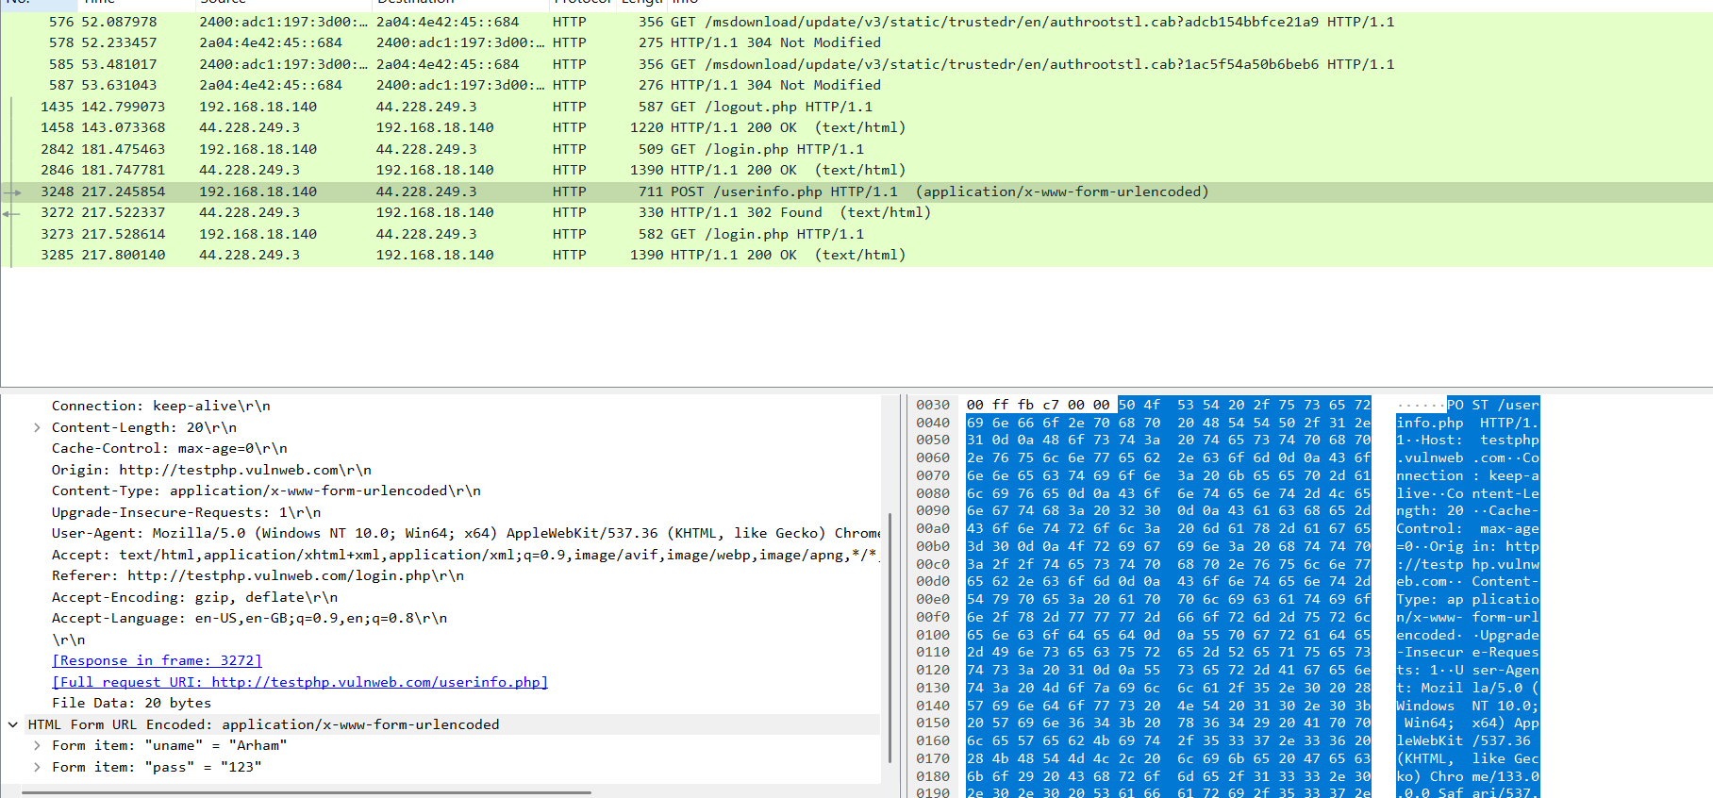
Data is unencrypted (Sensitive info Exposed)
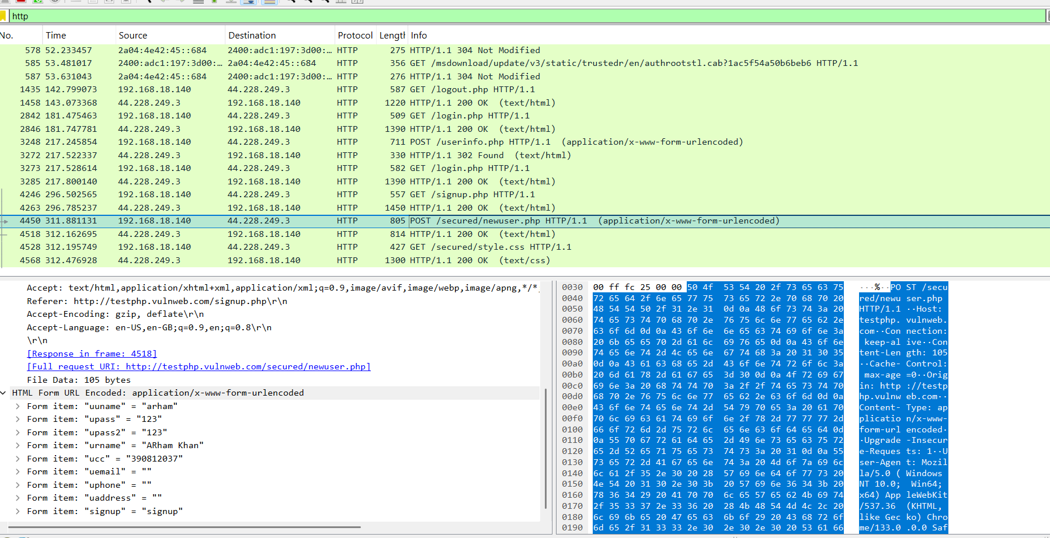
Now using HTTPS:
Data is encrypted using Transport Layer Security

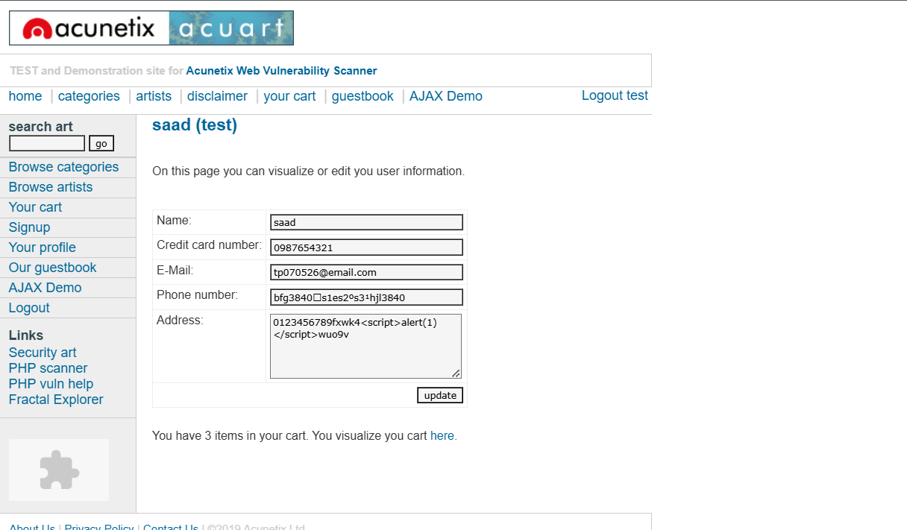
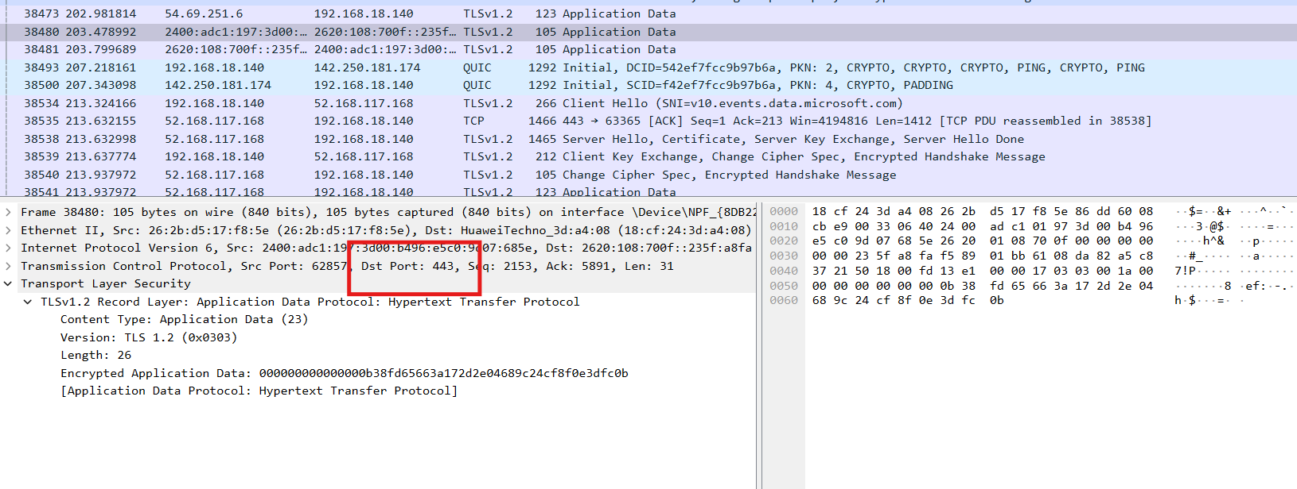
Difference between http and https:
HTTP packet is unencrypted and uses port 80, while an HTTPS packet is encrypted (TLS/SSL) and uses port 443;

